**HOW TO BREED TURTLES IN MINECRAFT**

In this article, you will come to know how to breed turtles in Minecraft. Turtles are the type of sea animal. Turtles can walk and about on land as well as float in water. On land, they travel slowly, but in the sea, they can swim quickly. They wander about aimlessly, like other passive mobs, and flee when threatened. When they're on land, they try to get to the nearest water source that has direct sky access.

Now we are going to learn how to breed the sea turtles briefly in our article. Sea Turtles are passive creatures in the game, which means they do not fight back when targeted. It is an important fact to remember as turtles usually get attacked by many Minecraft creatures from Ravages to Zombies.

**REQUIRED ITEMS:**

* 2 Sea Turtles
* Seagrass

**How Turtles looks:**

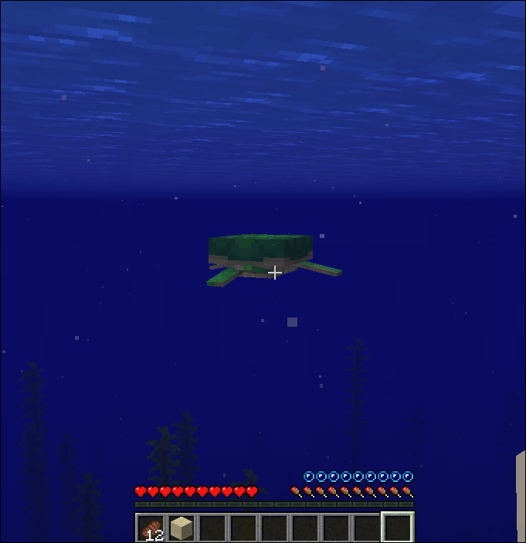

**steps to breed sea turtles:**

**Step1:** Our first step to breed turtles is we need to find and collect at least sea turtles and they should be parent turtles. Baby turtles can’t breed.

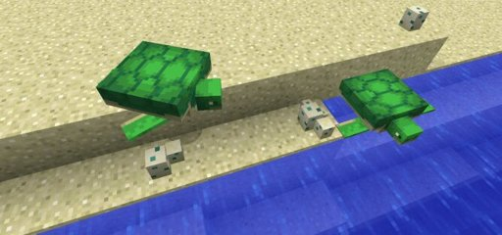

**Step2:** After bringing the sea turtles to the land we need to feed them with any type of seagrass.

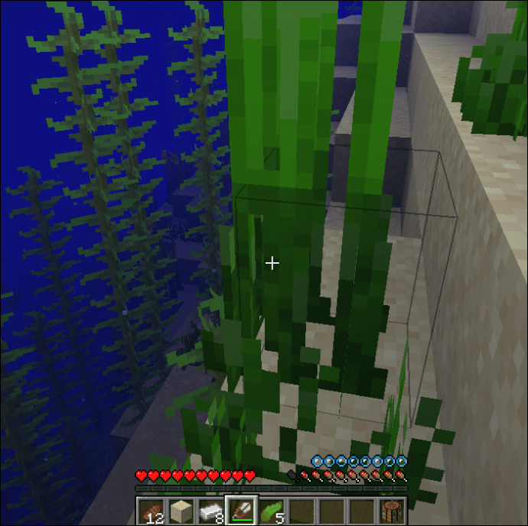

**Step3:** After feeding the turtles with seagrass, they will start breeding. You will come to know whether they are breeding or not by the sign of red hearts above them.

**Step4:** After completion of breeding one of the parent turtles will dig the sand around it and it will lay the eggs.

Now, all that remains is waiting for the baby Sea Turtles to hatch. They will only hatch at night-time, so don’t stand around in anticipation in daylight. To grow a baby Sea Turtle into an adult, feed it ten Seagrass items.

These are the steps to breed sea turtles.

**Sea Turtle Behaviour and Egg Mechanics**

Sea Turtles are passive Minecraft creatures. That means that they won’t fight back when attacked. This is important to keep in mind because the turtles are occasionally attacked by various Minecraft creatures, from Zombies to Ravages. If you’re planning on creating a Sea Turtle farm, prepare to put some defensive measures in place. Additionally, keep in mind that, although Sea Turtles are slow on dry land, they are fast in the water. Knowing this should help you round them up easier.

Once laid, Sea Turtle eggs are extremely brittle. If you or another Minecraft entity stands on an egg, the chances are that it will break. Additionally, dropping an egg will likely result in it breaking. So, be careful with them. Bear in mind that adult turtles can also break eggs. Keep the eggs safely tucked away.

Turtles will only lay eggs at their home beach or at a location where turtles have already laid eggs. If the turtles are not at their home beach, they will try to swim there before digging and laying their eggs.

**Uses of turtles in Minecraft:**

Turtle shells are **wearable items that let players breathe a little longer underwater**. Wearing a turtle shell in a helmet slot, while out of water or in a column of bubbles, will give the player a “water breathing” status effect, which only starts counting down when the player submerges.

**If Your turtles don’t lay eggs:** Turtles only lay eggs when there are **multiple layers of sand beneath them**. If there is only one layer of sand before a layer of stone or some other material, they will not lay eggs. In Minecraft, turtles only lay eggs on their “home beach.” This is where the turtles have hatched themselves or spawned. You cannot move live turtles to a new location and expect them to lay eggs after breeding. If you wish to move turtles to a new location, first breed them where they spawned. Then, move their unhatched eggs to your new location. When the eggs hatch, your baby turtles will recognize wherever you moved them as their home beach. Also, turtles only lay eggs when there are multiple layers of sand beneath them. If there is only one layer of sand before a layer of stone or some other material, they will not lay eggs. Hope this helps!

Turtles do not tend to lay eggs in the daytime, they mostly choose to lay the eggs at night-time. The baby turtles use electric streetlights or the moon as a source to travel at night-time

**Conclusion:** I hope this article helps you a lot in how to breed turtles in Minecraft. As you know Minecraft is one of the most famous educational games made for every age. Be careful that you stand away while the turtle lays the eggs and they mostly lay the eggs at night durations.

**Article by,**

Noone Harshan,

+919550949044